Task 1:

- Match the graphs to the equation, using the discriminant ($b^{2}-4ac$).

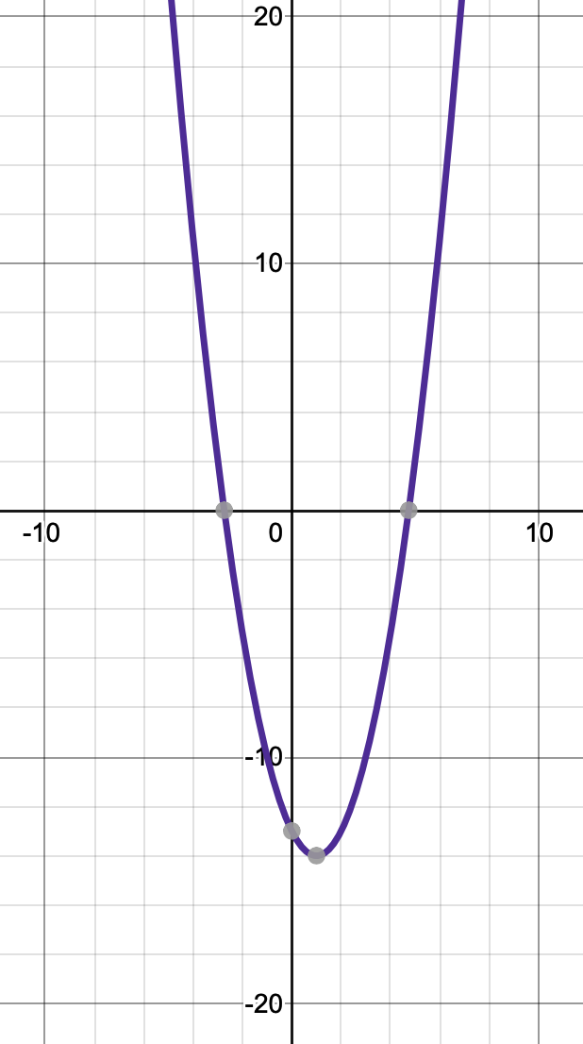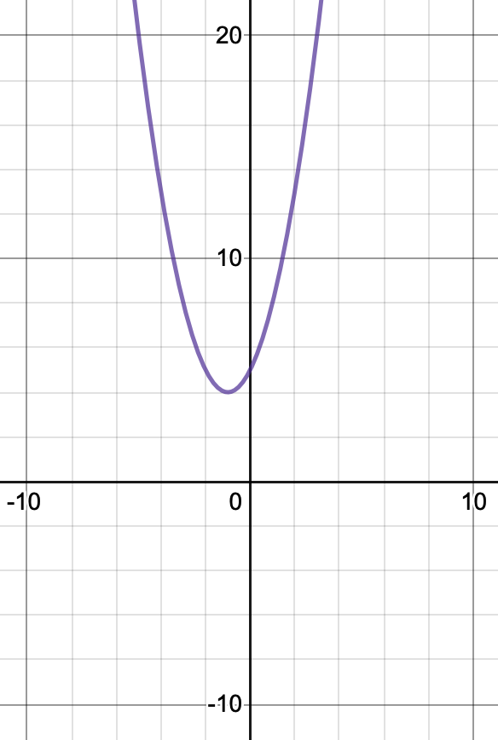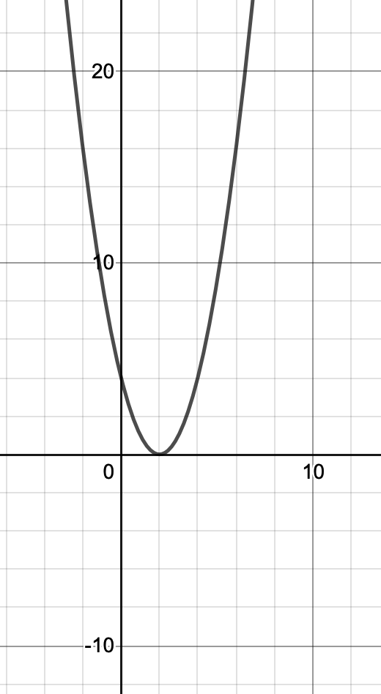

$$a) y=x^{2}-4x+4$$
$$b) {y= x}^{2}-2x-13$$
$$c) {y= x}^{2}+2x+5$$
Task 2

Find the nature of the roots for the following:
Use the discriminant!
- $h^{2}+5h+11=0$
- $x^{2}-4x-23=0$
- $y^{2}+2y-21=0$

Task 3

Fill in the table of values for y = x²+8x+15.
x | -6 | -5 | -4 | -3 | -2 | -1 | 0 | 1 | 2
y
- Use these as coordinates to plot the graph on a sheet of graph paper.
- How many roots are there?
- What is the discriminant?

Supporting notes:

Have a look at this link if you need a refresher on the discriminant:
https://www.bbc.co.uk/bitesize/guides/zcwhjty/revision/1

Answers:

  - $y= x^{2}-4x+4$. The discriminant is $b^{2}-4ac= {\left(-4\right)}^{2}-4 ×1×4=16-16=0.$ Therefore there is one real, repeated root. The graph touches the x axis once. This is the last graph.
  - ${y= x}^{2}-2x-13$. The discriminant is $b^{2}-4ac= {\left(-2\right)}^{2}-4 ×1×-13=4+52=56.$ This is positive so there are two real and distinct roots. The graph crosses the x axis twice. This is the first graph.
  - ${y= x}^{2}+2x+5$. The discriminant is $b^{2}-4ac= {\left(2\right)}^{2}-4 ×1×5=4-20=-16.$ This is negative so there are no real roots. The graph does not cross the x axis. This is the middle graph.

  - No real roots.
  - Two real and distinct roots.
  - Two real and distinct roots.

x | -6 | -5 | -4 | -3 | -2 | -1 | 0 | 1 | 2
y | 3 | 0 | -1 | 0 | 3 | 8 | 15 | 24 | 35
  - 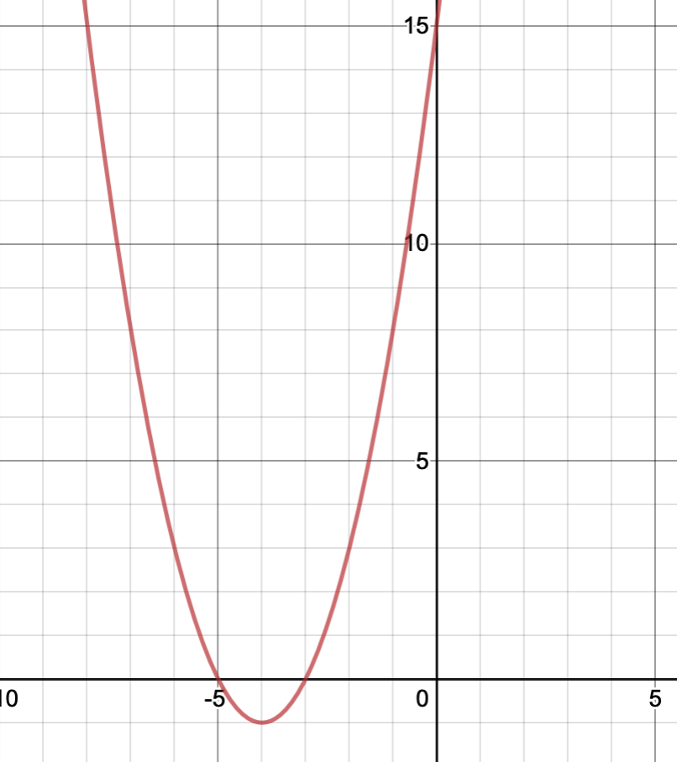
  - 2 real and distinct roots
  - y = x²+8x+15. The discriminant is $b^{2}-4ac= {\left(8\right)}^{2}-4 ×1×15=64-60=4.$ This is positive which is what we expect because the graph shows two real and distinct roots.

